Open the page:

<https://developer.yammer.com/docs/messages-json-post>

click log in

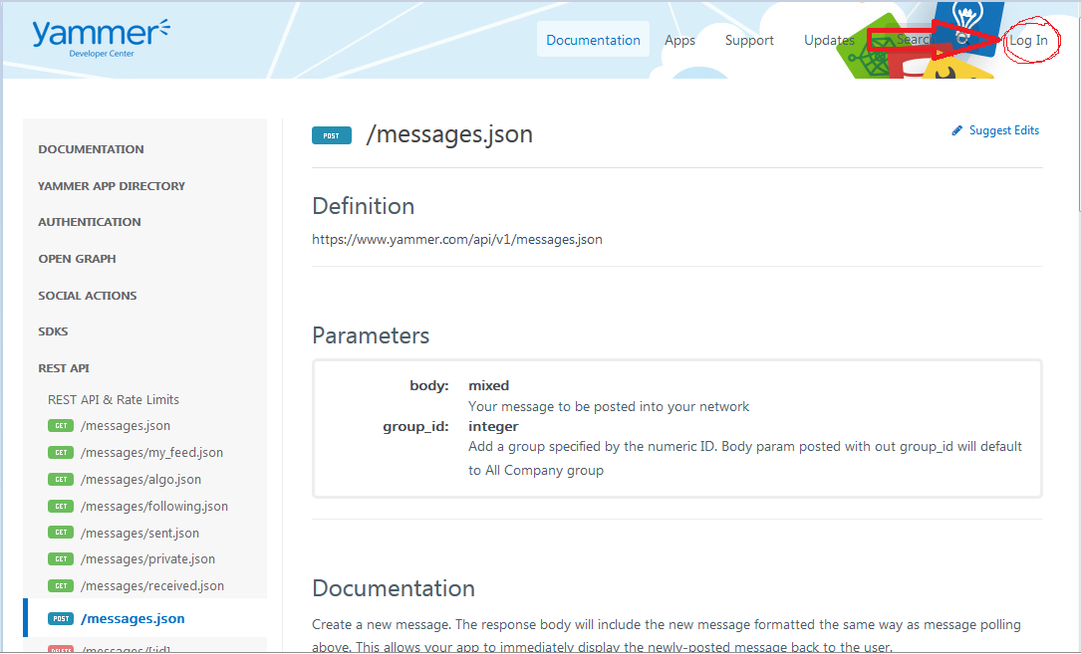

Input the user and the password , you will get this page

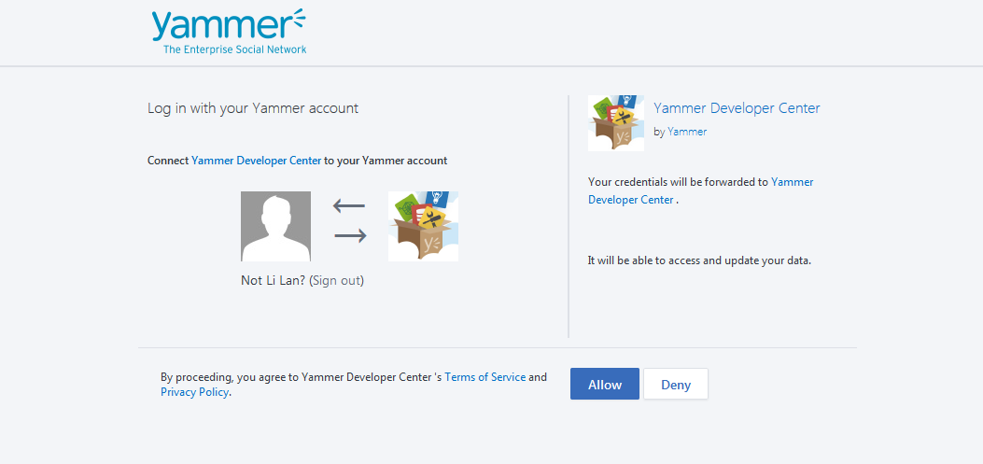

Click Allow

Then get the page down

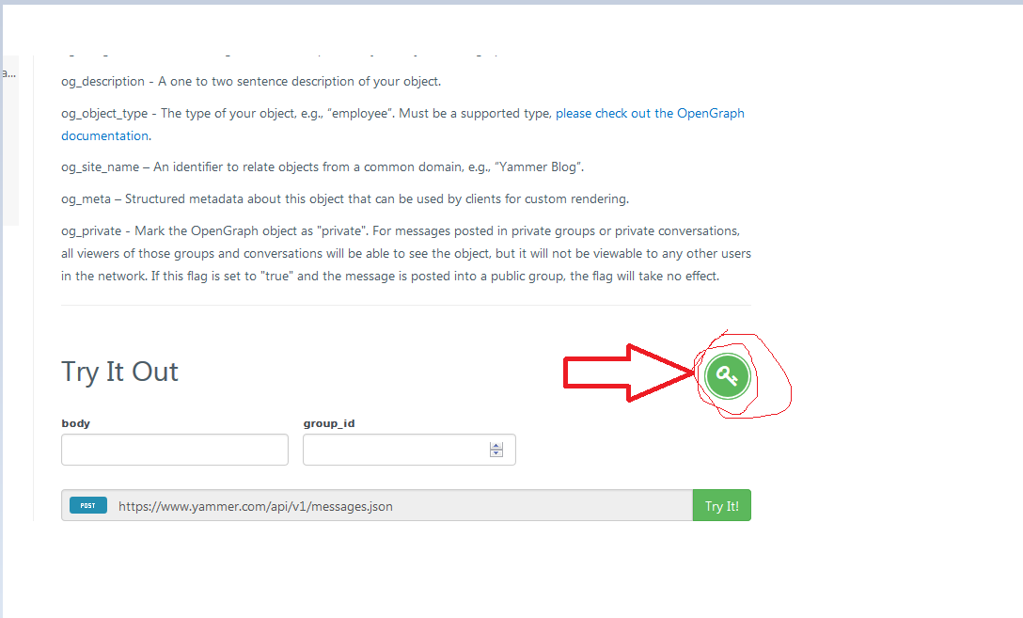

You will get he token on the box.

